* [LinkedIn](http://www.linkedin.com/in/richmond-siame)

Flamingo Company Retail Analysis.

End-to-End Data Analysis Using Power BI.

The Flamingo Company is an online retail business operating in the United States. The company trades in three segments: Consumer, Corporate, and Home office and has three categories: Technology, Office Supplies, and Furniture and seventeen Sub-Categories.

**Understanding the Context**.

The Marketing and General Manager require a breakdown of the Company’s sales performance to make informed decisions to drive business growth.

**Role as a Data Analyst**.

As a Data Analyst, provide a detailed Explanatory Analysis of the sales performance to the Marketing and General Manager to enable informed decision-making.

**Stakeholder Engagement.**

I identified and interviewed key stakeholders, and asked questions that steered the analysis towards achieving the project goals.

|  |  |  |
| --- | --- | --- |
| Stakeholder Name: Andrew | | Position: Retail Manager |
| Question | | Answer |
| 1 | How do you select the best-performing city? | The city with the highest overall profit. |
| 2 | How do you select a ship mode to leverage for more profit? | The Ship mode with the highest total profit. |
| 3 | In terms of profit per state, how do you define a successful business? | A state which did not record any loss. |

|  |  |  |
| --- | --- | --- |
| Stakeholder Name: Clark | | Position: General Manager |
| Question | | Answer |
| 1 | What KPIs do you normally base decisions on? | The total revenue and profit. |
| 2 | How do you determine competition among the regions? | The region with the highest profit and how it compares with others. |
| 3 | Which category would you like to improve? | The category with the lowest total profit. |

**Data Preparation and Modelling**.

Data source: [Retail Supermarket (kaggle.com)](https://www.kaggle.com/datasets/roopacalistus/superstore)

The data contained the following columns: Ship Mode, Segment, Country, City, State, Postal Code, Region, Category, Sub-category, Sales, Quantity, Discount and Profit.

Steps

1. Utilized built-in Power Query function in Power BI to load Comma Separated Value (CSV) data.
2. Renamed columns to enhance clarity.
3. Used the column quality, column profile and column distribution features of the view tab to inspect data accuracy.
4. Assigned correct data types to the following columns:

|  |  |
| --- | --- |
| Column Name | Assigned Data type |
| Ship Mode | Text |
| Segment | Text |
| Country | Text |
| City | Text |
| State | Text |
| Postal Code | Whole Number |
| Region | Text |
| Category | Text |
| Sub-category | Text |
| Total Sales | Fixed Decimal |
| Quantity | Whole Number |
| Discount | Percentage % |
| Profit | Fixed Decimal |

1. Removed Duplicates: The Row count in the column profile before and after removing duplicates remained unchanged, meaning duplicates were absent in our data.
2. Sorted the Total Sales and Profit columns.
3. Applied currency data type to the Total Sales and Profit column in the (choose how the values in this column are displayed) field in the Table view of Power BI Desktop. Doing this will display the chosen currency symbol (in this case the $ sign) against the column values in the visualization but does not impact how they are stored.
4. Applied data Categories to the following columns in the properties pane of the Table view.

|  |  |
| --- | --- |
| Column Name | Applied Category |
| Country | Country |
| City | City |
| State | State/Province |
| Postal Code | Postal Code |

Applying data categories informs Power BI on how to treat certain columns which in turn aids in visualization.

1. Created a Data Analysis Expression (DAX) measure using the (SELECTEDVALUE) function to display a state name upon selecting a state in the shape map visual.

**Visualization and Analysis**.

Followed below effective data storytelling principles to design interactive visuals to answer business questions.

* Understanding of context: Identified the audience and what they need to know.
* Choosing appropriate visuals: I determined the data I wanted to show and chose the best visual to display by considering the level of understanding of the technical audience.
* Eliminated clutter: Reduced audience cognitive load by eliminating clutter (visual elements that take up space but don’t increase understanding).
* Drawing attention to where I want the audience to focus: Leveraged pre-attentive attributes such as colour, size, and position on the page to direct audience attention to where I want them to focus, and to create a visual hierarchy of elements to lead my audience through the information I want to communicate.
* Used Adobe Photoshop to leverage preattentive attributes to help the audience process information.

**Visualizations.**

1. A Shape map visual showing **total profit** by **State** and a **Segment and Sub-category** filter.

* Created a **custom tooltip** to display **profit by category** upon selecting a state.
* Used colour to differentiate profit from loss in the custom tooltip.

In this case blue colour for categories above zero (profit) and grey colour for categories below zero (loss).

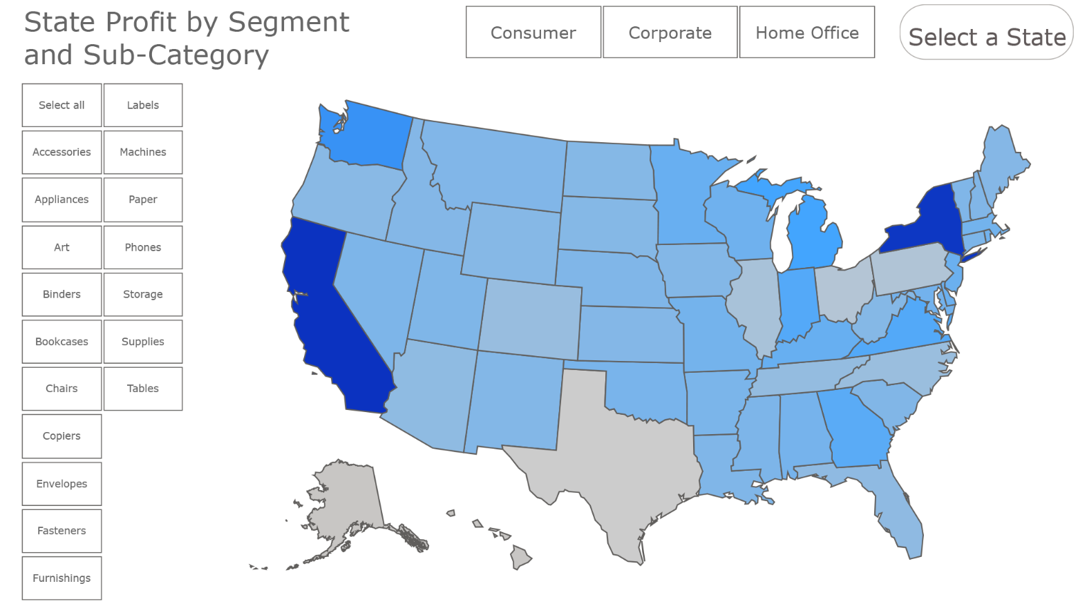

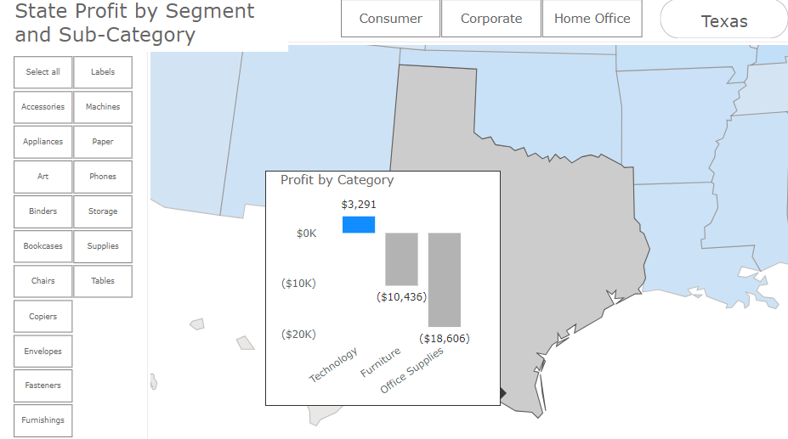

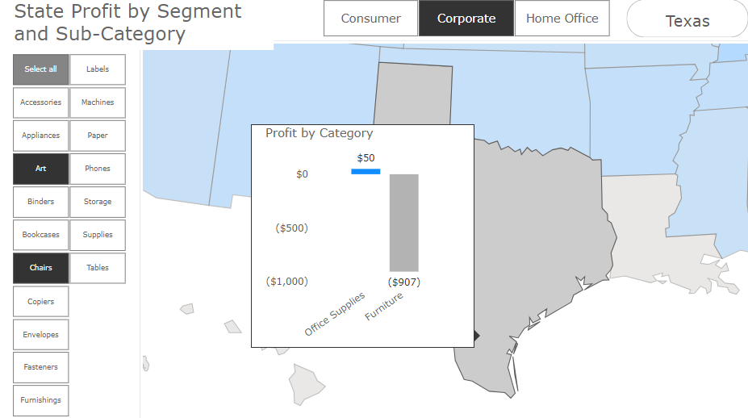

2. A column chart showing **Total Profit** by **Ship Mode**.

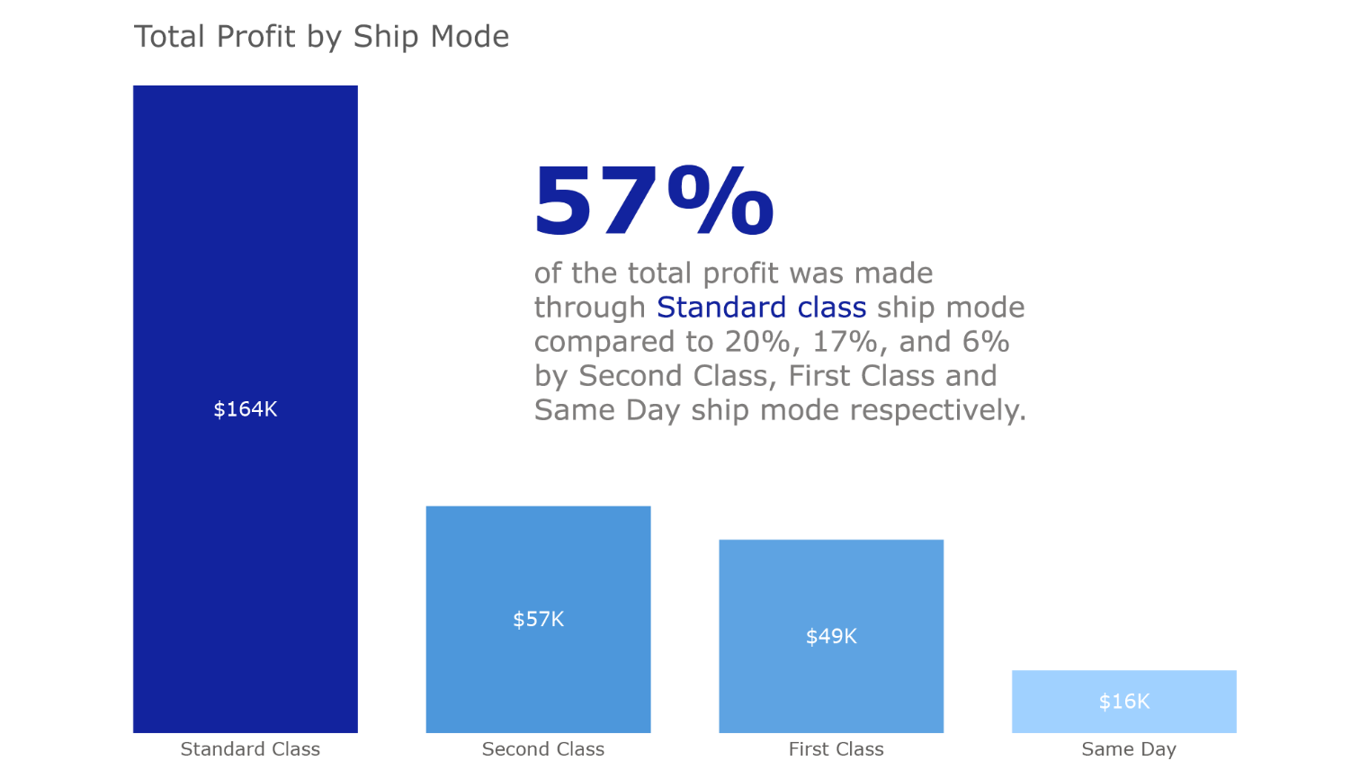

3. A stacked column chart showing **Total Sales** by **Segment** and **Category**.

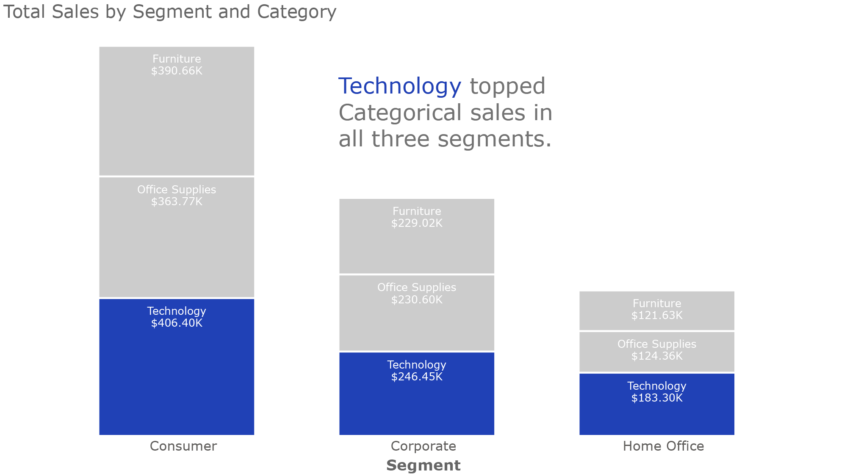

4. A matrix chart showing **Sales and Profit** by **Segment**, **Category and Sub**-**category**.

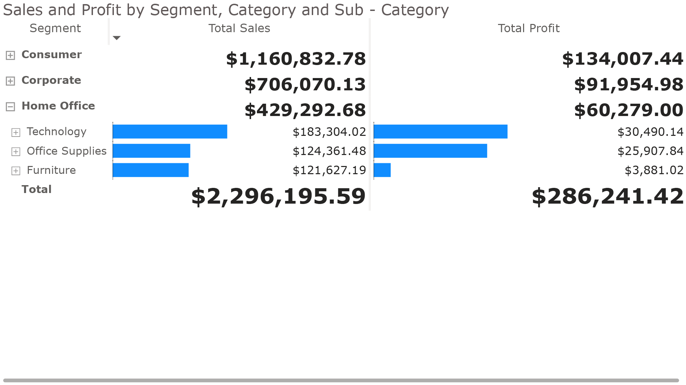

5. A Key Performance Indicator (**KPI**) dashboard showing the fundamental areas of performance metrics.

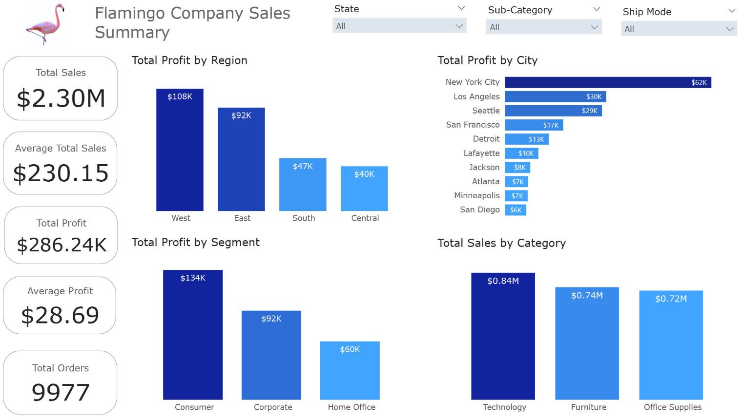

**Analysis.**

1. **New York City** earned the highest profit, an amount of **$ 62,013.90**.
2. **Standard Class** ship mode generated the highest profit, an amount of **$163,969.23** which is **57%** of the total **profit**.
3. States like **California**, **New York**, and **Georgia** did not record any loss compared to a state like **Texas** which recorded a profit of **$3,291** in **Technology** and a loss of **$-10,436** and **$-18,606** in the **Furniture** and **Office supplies** category, respectively.
4. The **total revenue** and **total profit** are **$2,296,195.59** and **$286,241.42,** respectively.
5. At **$108,329.81**, **West** had the highest sum of **Profit** and was **173.17%** higher than **Central**, which had the lowest sum of **Profit** at **$39,655.88**.﻿

* **West** had the highest sum of **Profit** at **$108,329.81**, followed by **East**, **South**, **and Central.**
* **West** accounted for **37.85%** of the sum of Profit.
* Across all **4 Regions**, the sum of Profit ranged from **$39,655.88** to **$108,329.81**.

1. ﻿At **$145,454.95**, **Technology** had the highest sum of **Profit** and was **689.58%** higher than **Furniture**, which had the lowest sum of **Profit** at **$18,421.81**.

* **Technology** had the highest sum of **Profit** at **$145,454.95**, followed by **Office Supplies** at **$122,364.66** and **Furniture** at **$18,421.81**.
* **Technology** accounted for **50.82%** of the sum of **profit.**
* **Technology** had **$145,454.95** sum of **profit**, **Office Supplies** had **$122,364.66**, and **Furniture** had **$18,421.81**.

Richmond Siame.

Data Analyst.

[richmonddonewell.sme@gmail.com](mailto:richmonddonewell.sme@gmail.com).

<http://www.linkedin.com/in/richmond-siame>

<https://github.com/RichAero>